TALENT REPORT

***A-Gabriel Bell***

*Partner | Latham Watkins LLP | DC*

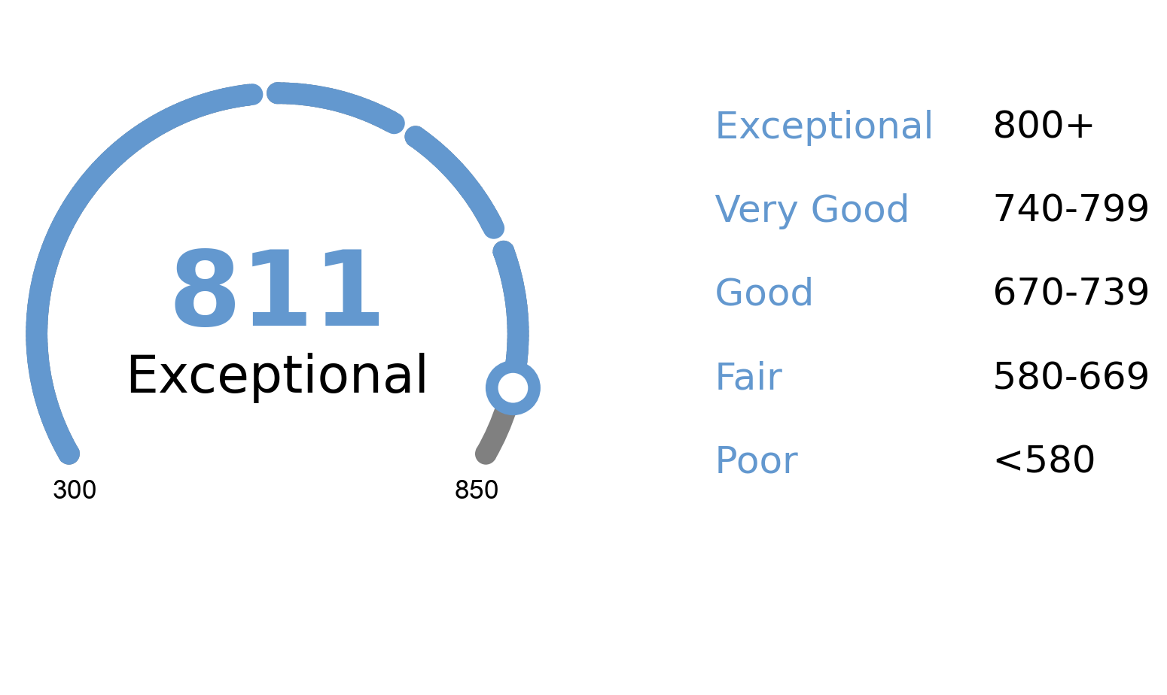

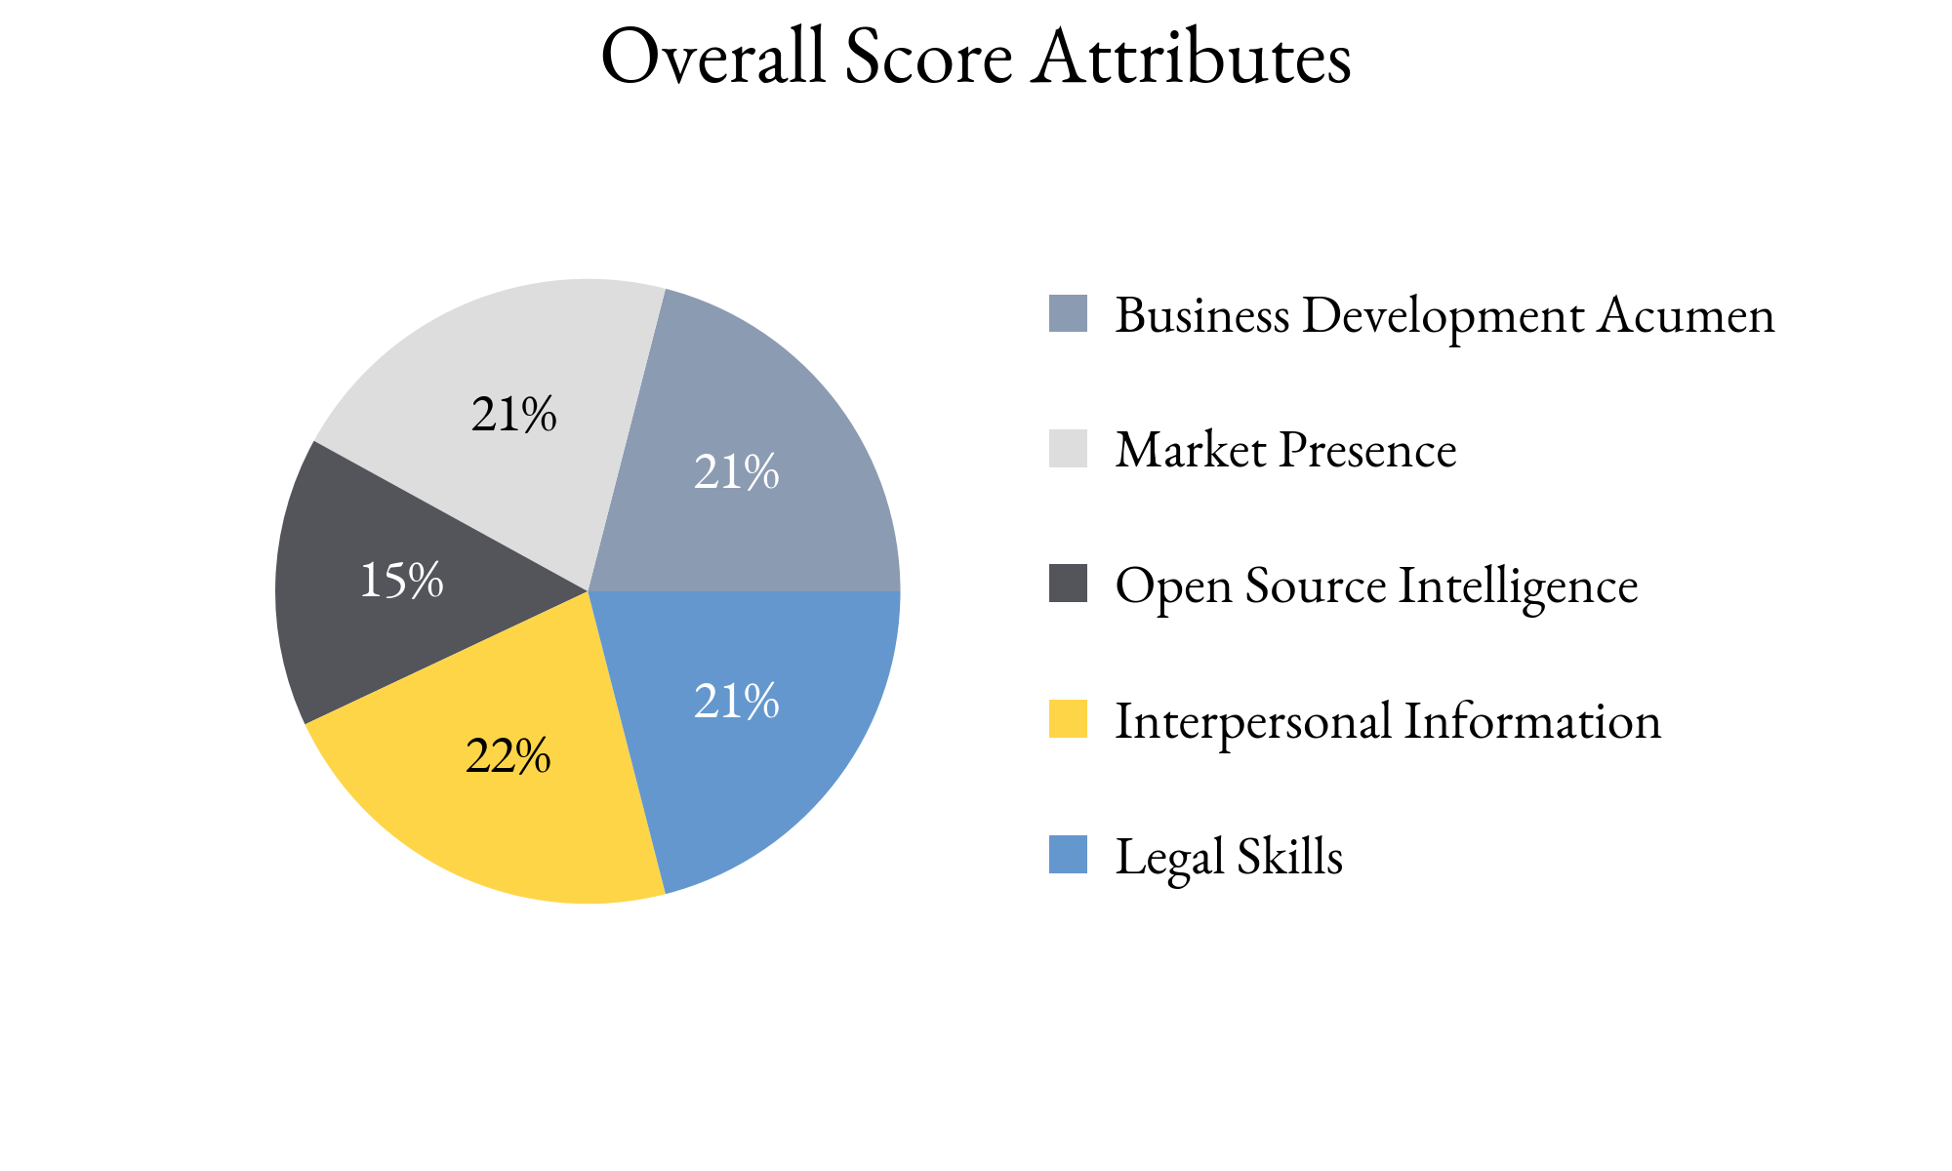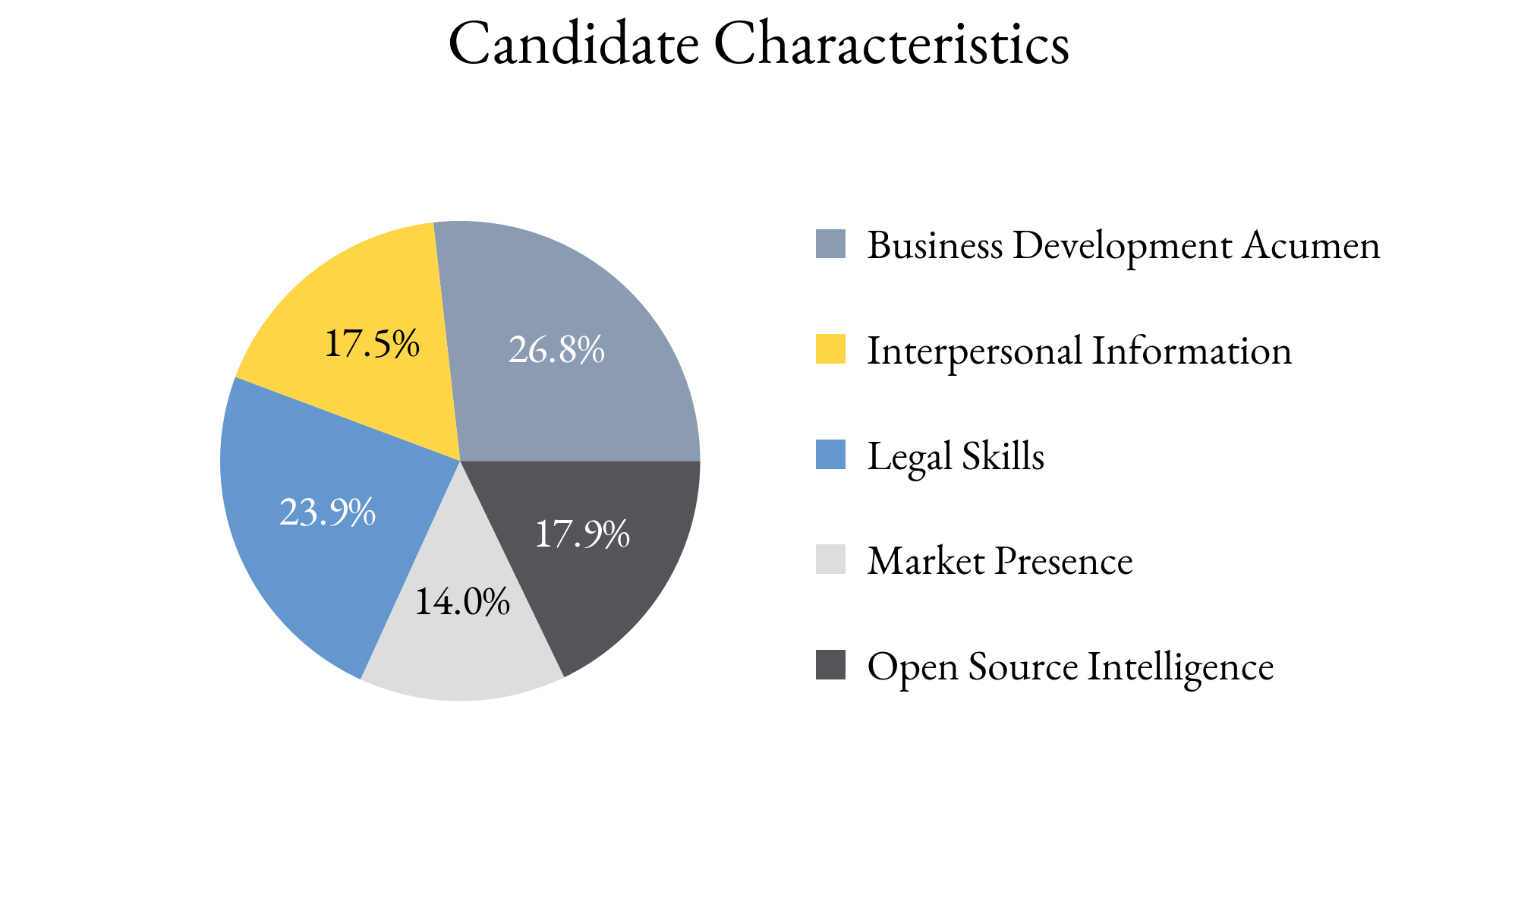

Highlighting Factors:

* No outside business
* Has not moved firms very often

Limiting Factors:

* Market peers have not heard of the candidate
* Poor reputation with peers

TIA analysts assess this score with **(*High, Medium, Low*)** confidence

based on the information able to be attained.

TIA Candidate Score is derived from open-source information as well as human intelligence gathered about the candidate utilizing an artificial intelligence platform with machine learning technology. This platform takes into account the factors highlighted for each candidate, the credibility of the human intelligence sources, candidate characteristics and attributes as well as the confidence level of TIA analysts.