TALENT REPORT

***A-Rudy Kim***

*Partner | | None*

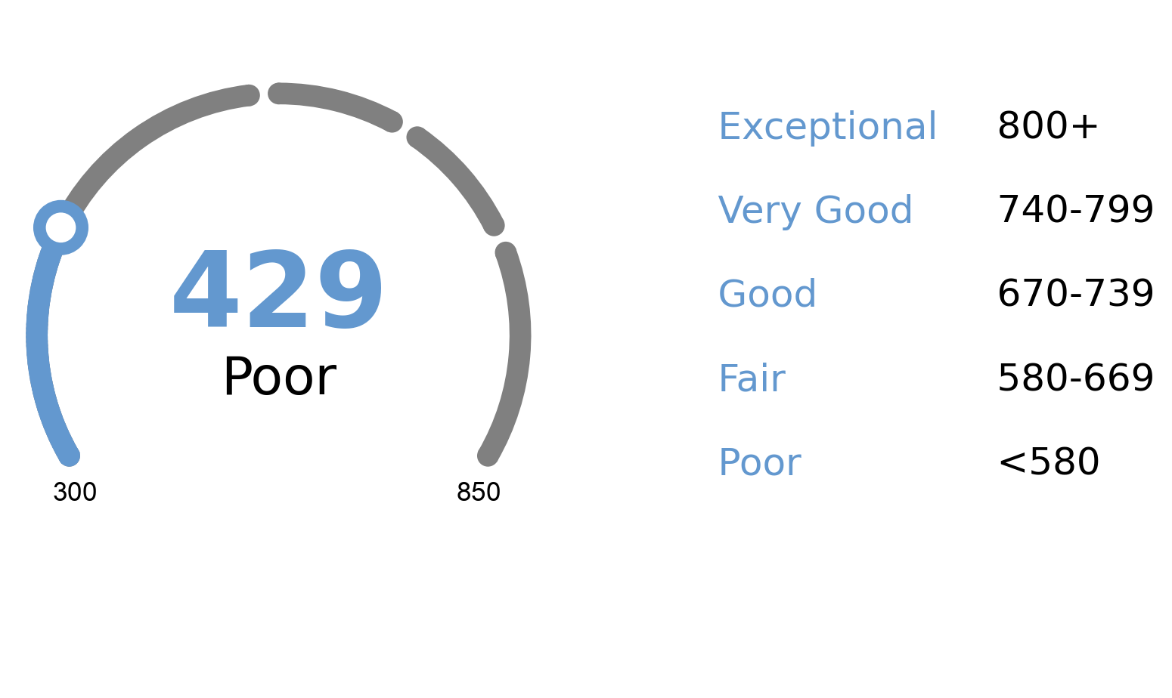

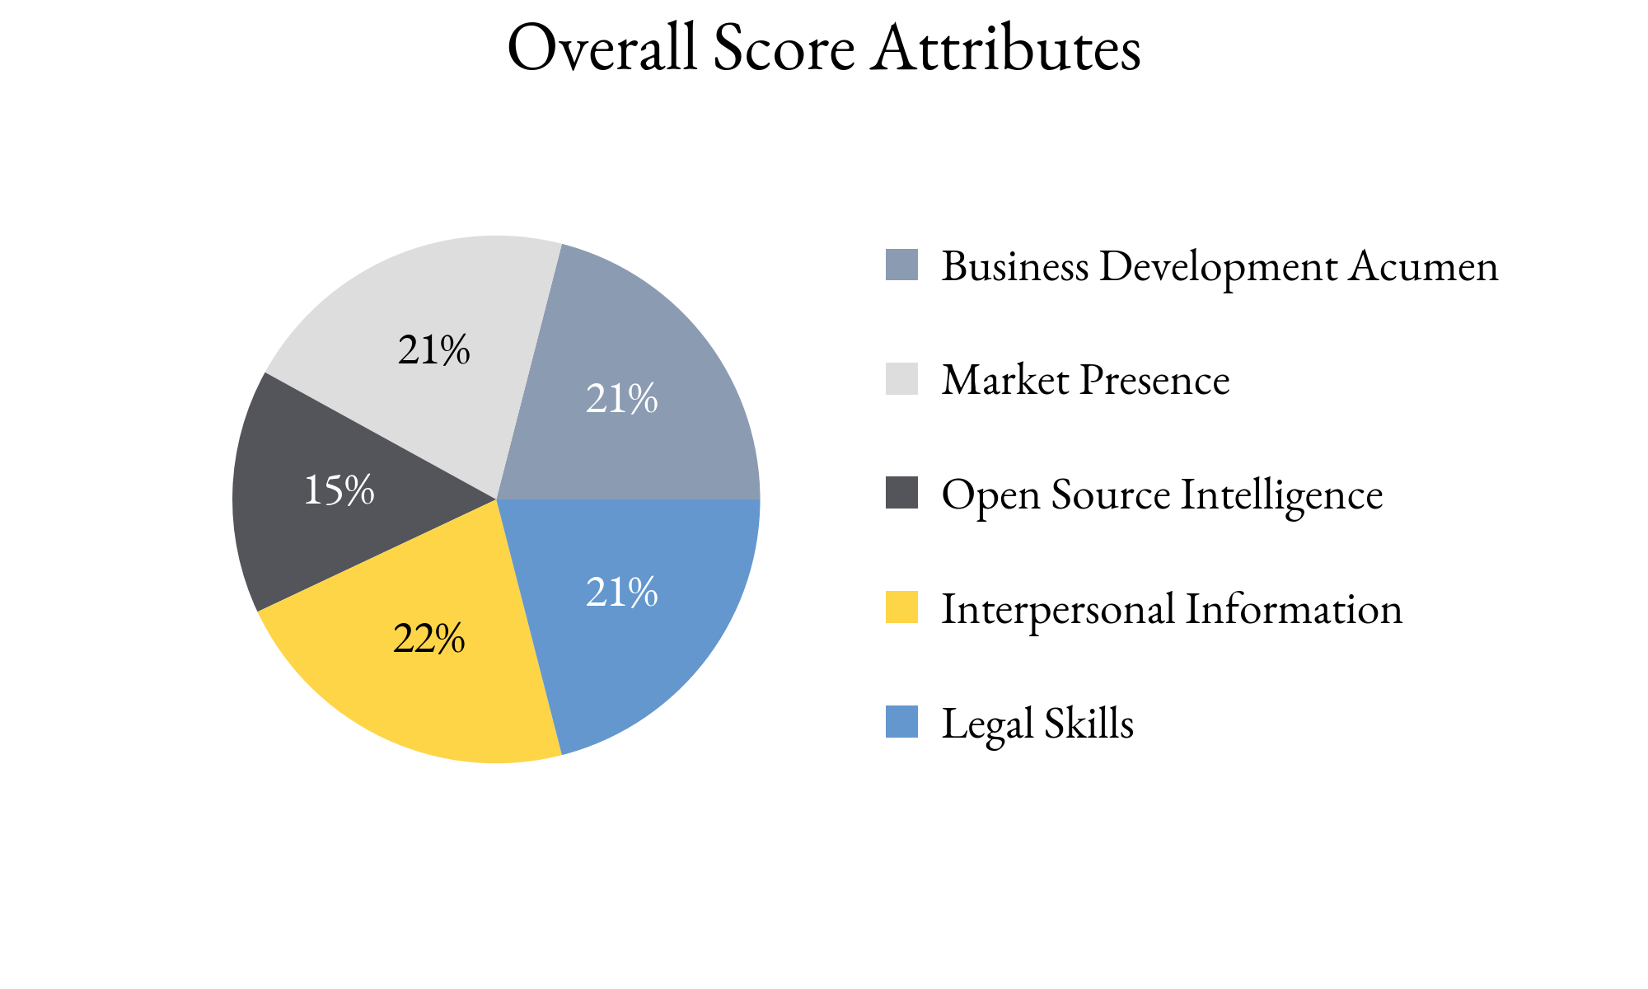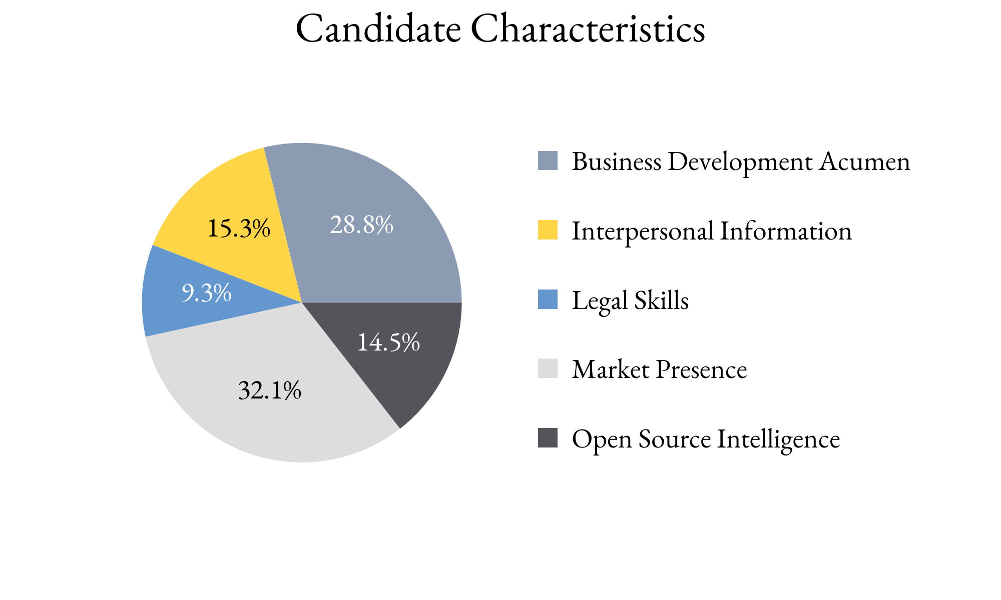

Highlighting Factors:

* Does pro bono and charitable work
* Makes a deliberate effort to be recognized in the media

Limiting Factors:

* Does not attend network events or virtually network
* Passively pursues new clients

TIA analysts assess this score with **(*High, Medium, Low*)** confidence

based on the information able to be attained.

TIA Candidate Score is derived from open-source information as well as human intelligence gathered about the candidate utilizing an artificial intelligence platform with machine learning technology. This platform takes into account the factors highlighted for each candidate, the credibility of the human intelligence sources, candidate characteristics and attributes as well as the confidence level of TIA analysts.