TALENT REPORT

***Beau Stapleton***

*Partner | Manatt, Phelps & Phillips, LLP | LA*

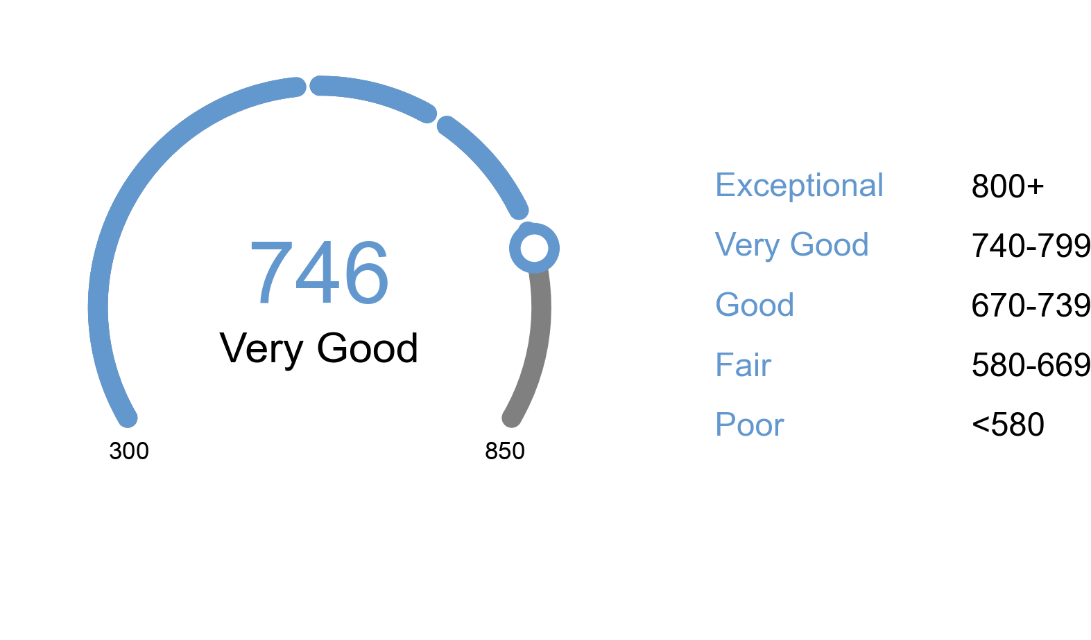

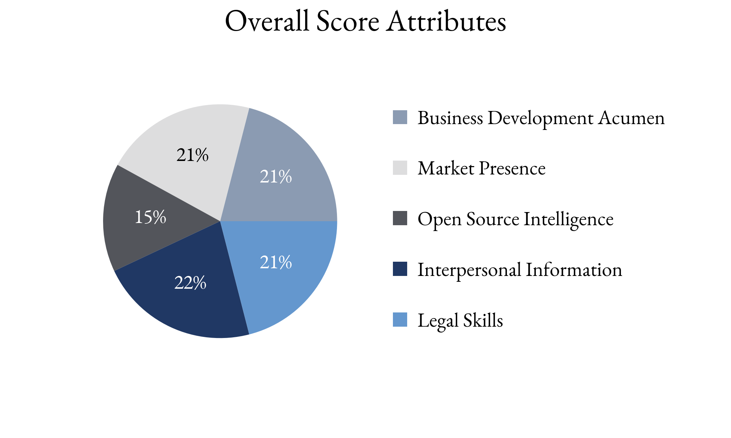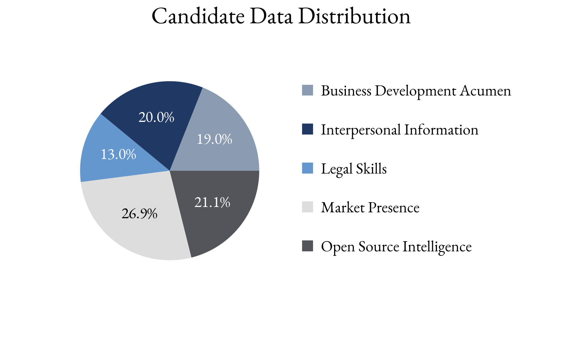

Highlighting Factors:

* Recognized for expertise
* Excellent reputation with peers
* Specific expertise

Limiting Factors:

* Lack of book growth compared to peers (last five years)
* Client satisfaction unclear
* Supports but may not lead deals

TIA analysts assess this score with **(*High, Medium, Low*)** confidence

based on the information able to be attained.

TIA Candidate Score is derived from open-source information as well as human intelligence gathered about the candidate utilizing an artificial intelligence platform with machine learning technology. This platform takes into account the factors highlighted for each candidate, the credibility of the human intelligence sources, candidate characteristics and attributes as well as the confidence level of TIA analysts.