TALENT REPORT

***Daniel Dubelman***

*Partner | Massumi + Consoli LLP | Los Angeles, California*

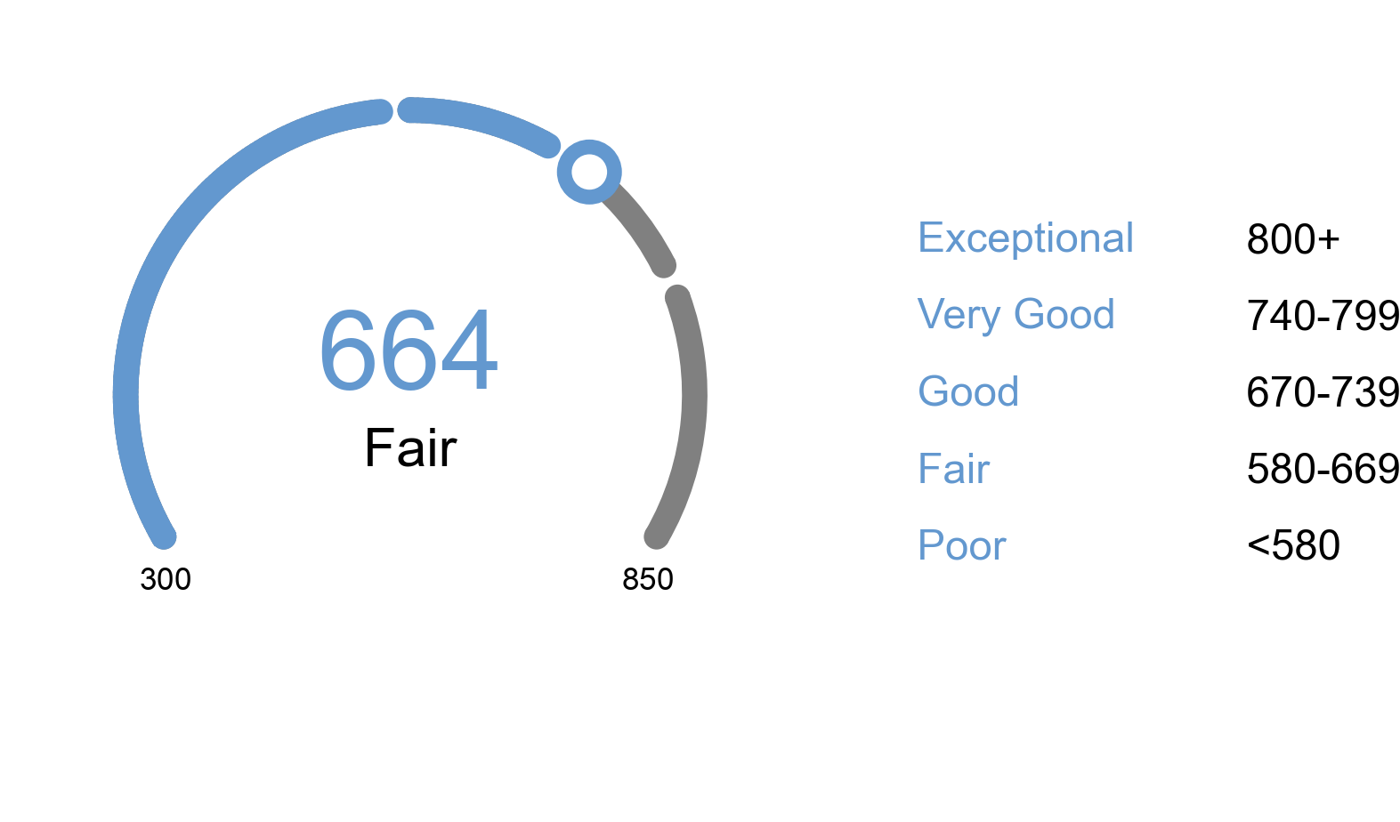

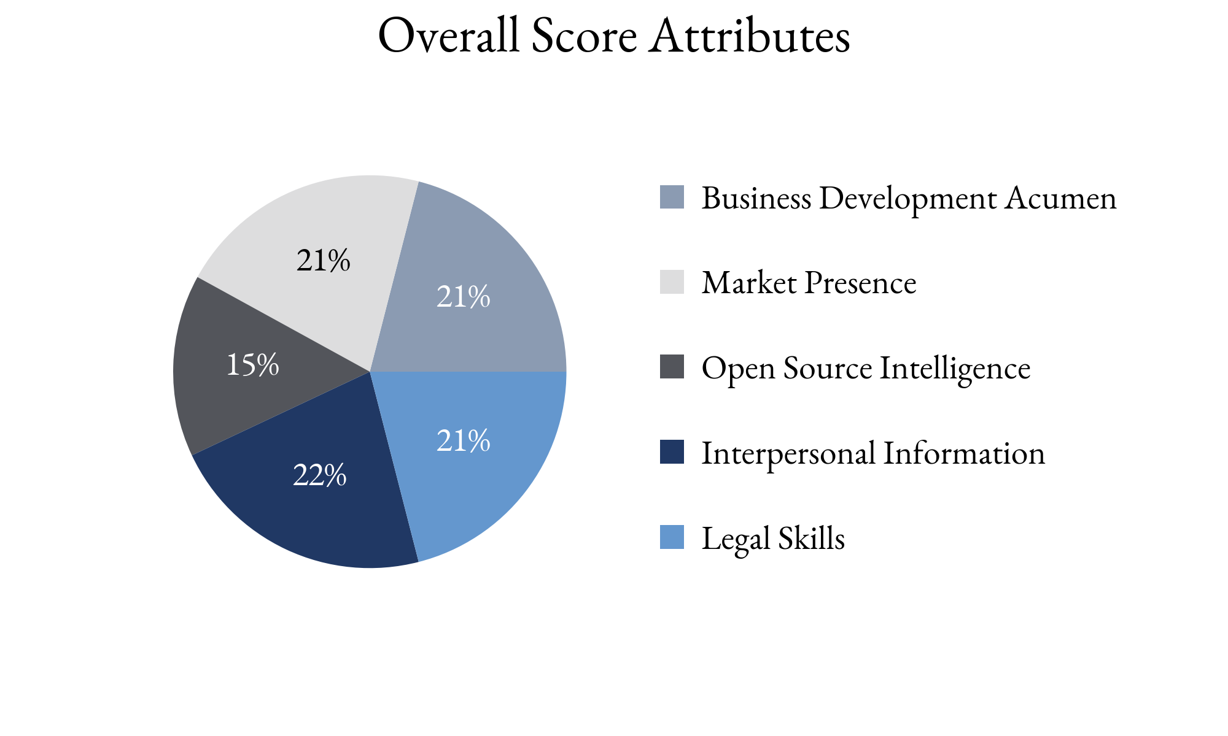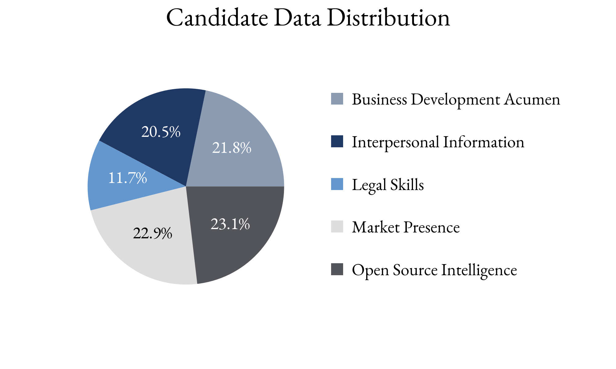

Highlighting Factors:

* Excellent reputation with peers
* Recognized for expertise
* Fits the client's specific requests

Limiting Factors:

* No evidence of referrals from peers or clients
* Limited insight into book of business
* New client pursuit aggression unclear

TIA analysts assess this score with **(*High, Medium, Low*)** confidence

based on the information able to be attained.

TIA Candidate Score is derived from open-source information as well as human intelligence gathered about the candidate utilizing an artificial intelligence platform with machine learning technology. This platform takes into account the factors highlighted for each candidate, the credibility of the human intelligence sources, candidate characteristics and attributes as well as the confidence level of TIA analysts.