TALENT REPORT

***Fidel Castro***

*Partner | Castro | Cuba*

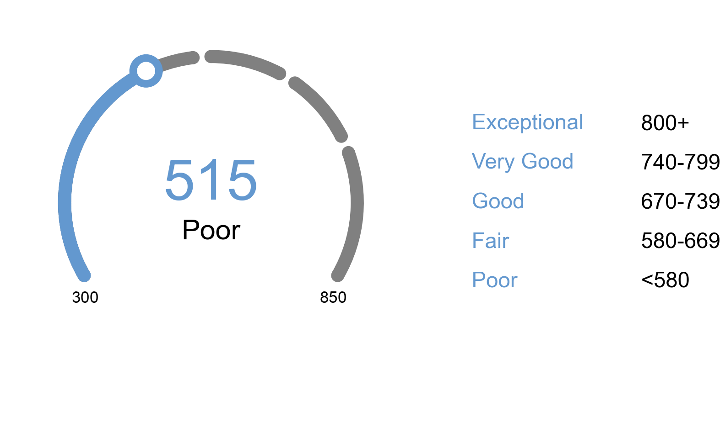

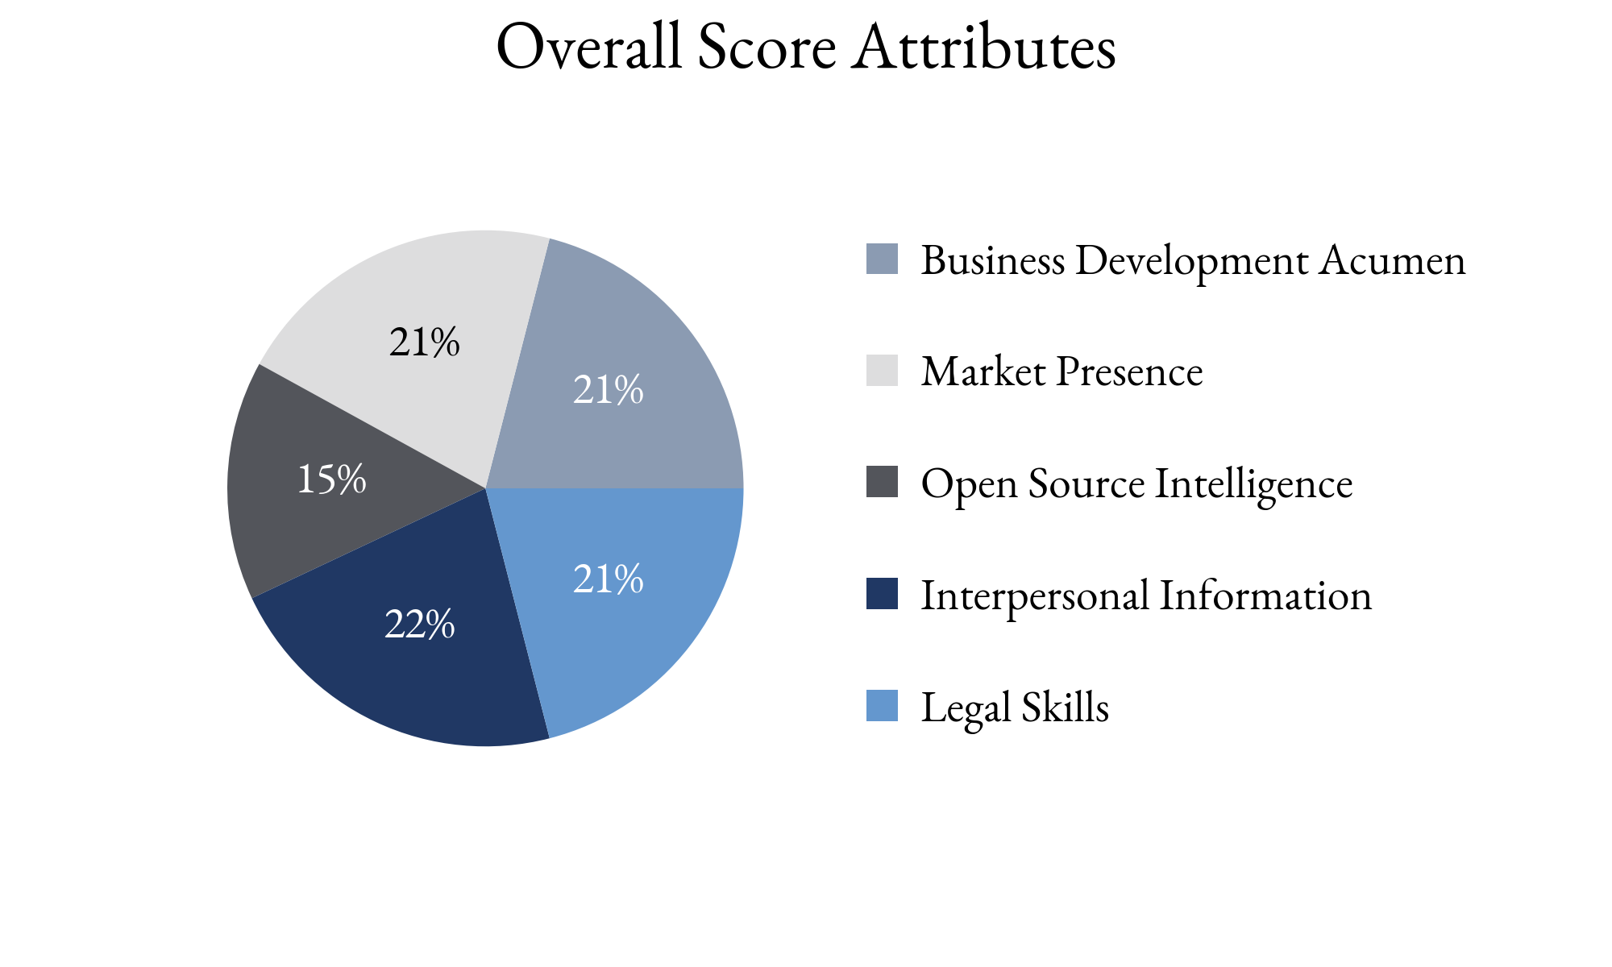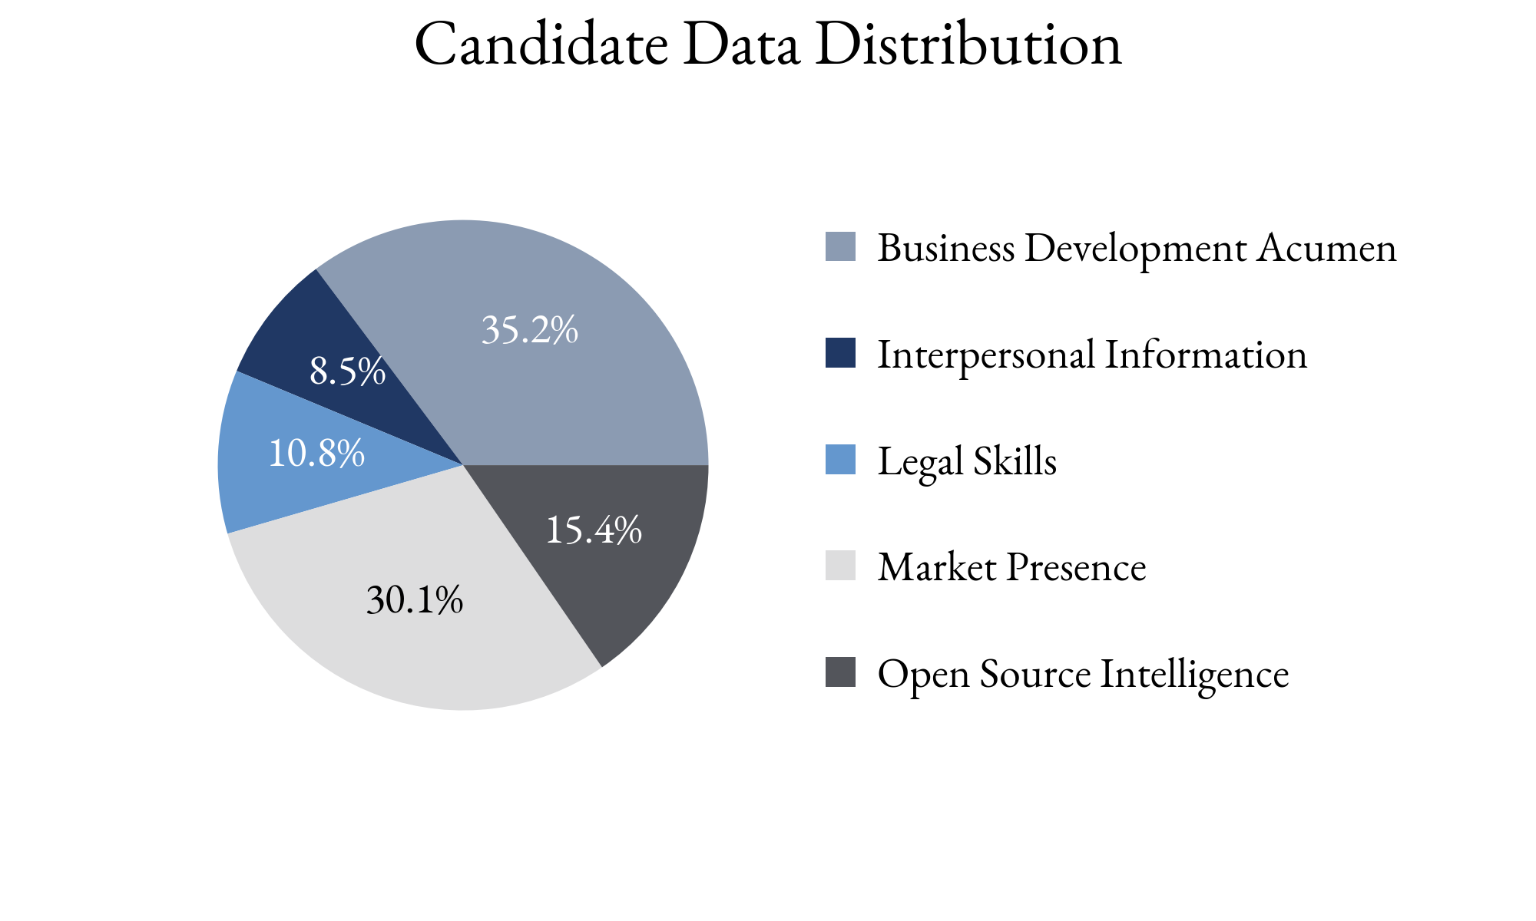

Highlighting Factors:

* High deal mentions in news
* Years of experience
* Specific expertise

Limiting Factors:

* Described as difficult to work with
* No evidence of referrals from peers or clients
* Client satisfaction unclear

TIA analysts assess this score with **(*High, Medium, Low*)** confidence

based on the information able to be attained.

TIA Candidate Score is derived from open-source information as well as human intelligence gathered about the candidate utilizing an artificial intelligence platform with machine learning technology. This platform takes into account the factors highlighted for each candidate, the credibility of the human intelligence sources, candidate characteristics and attributes as well as the confidence level of TIA analysts.