TALENT REPORT

***Harvey Specter***

*Partner | Pearson Hardman | New York, NY*

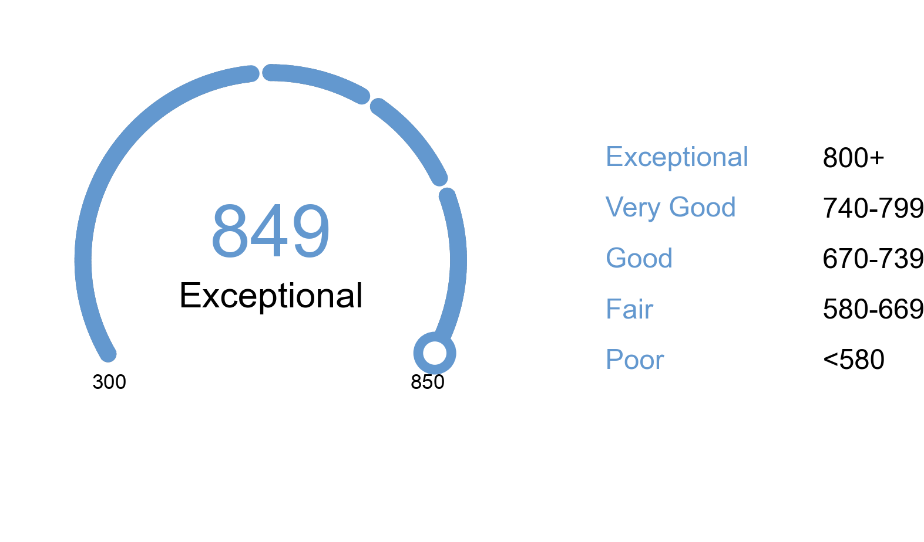

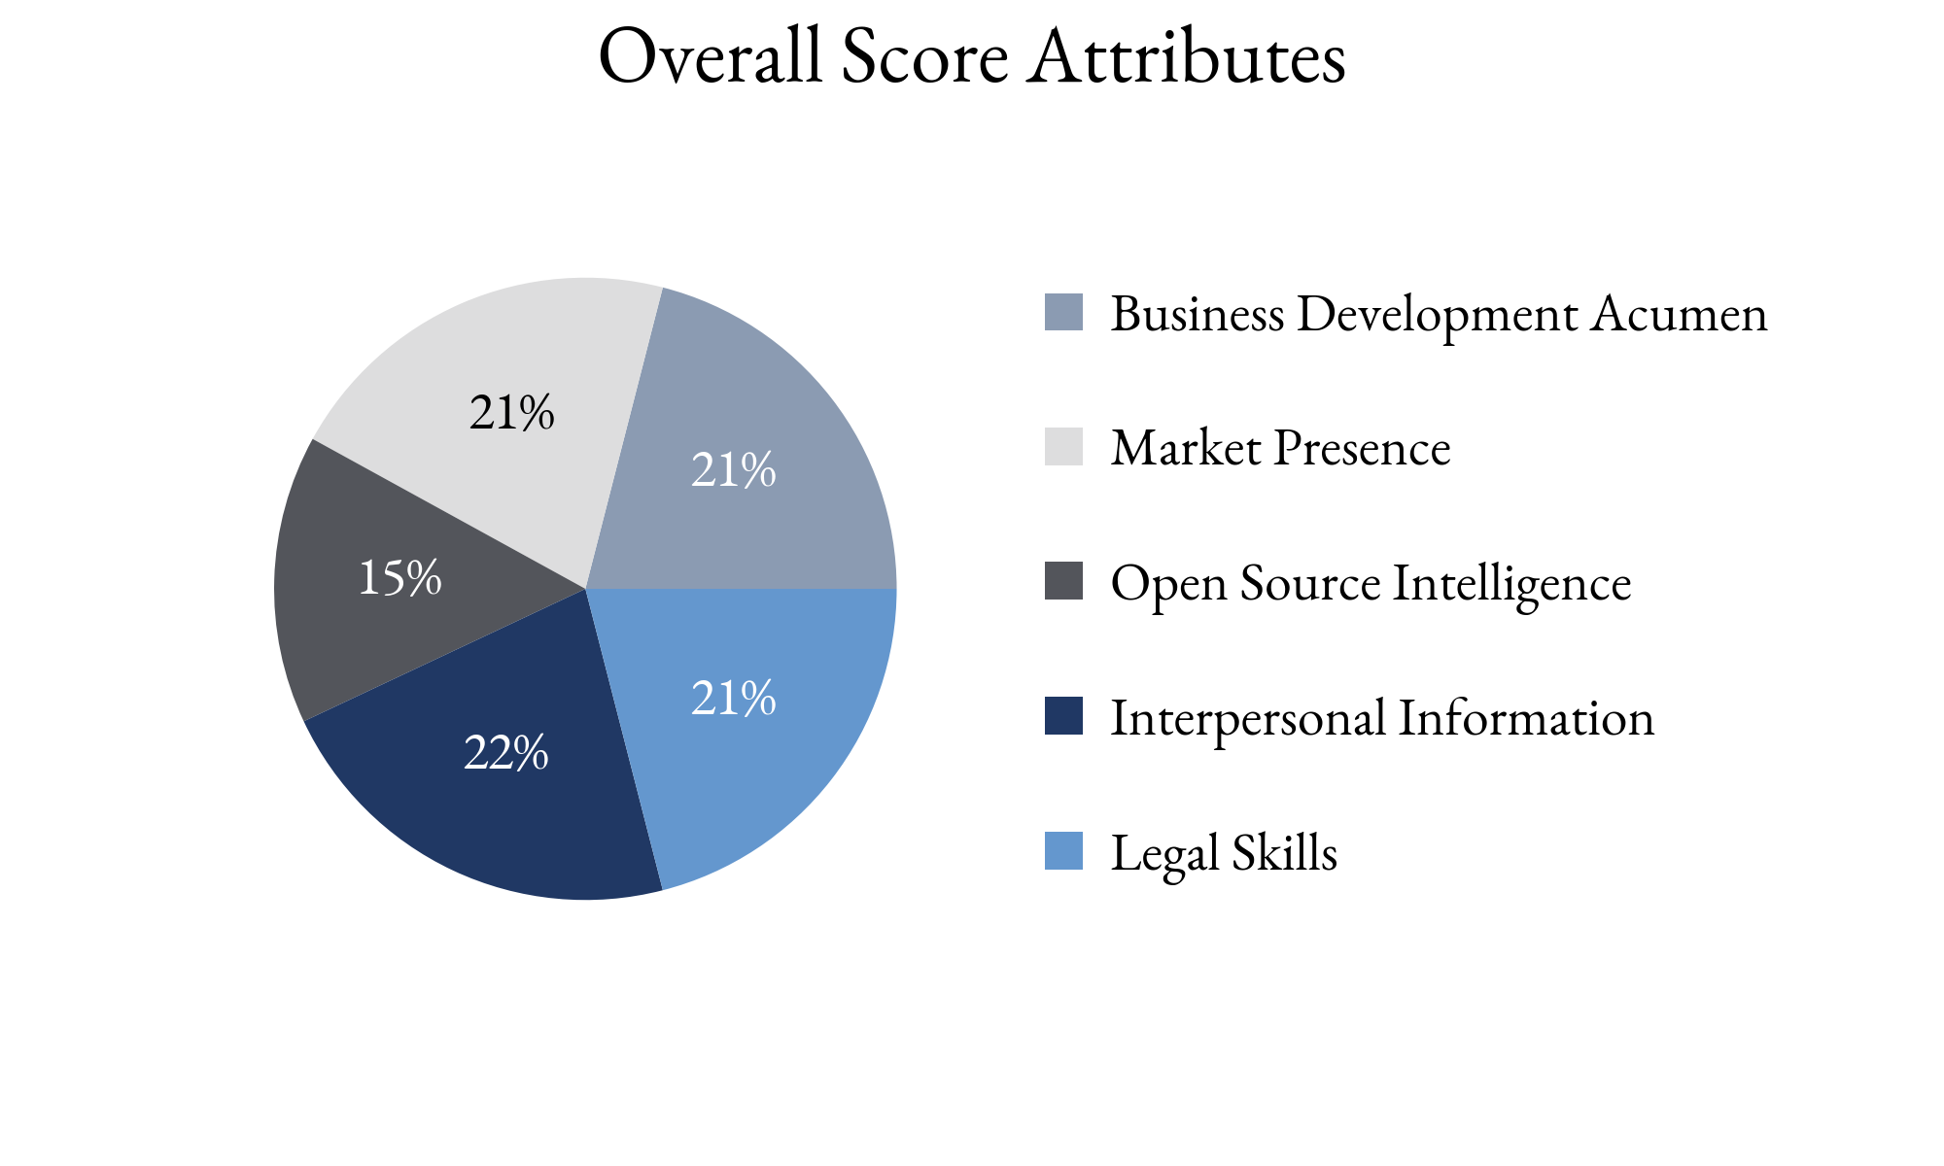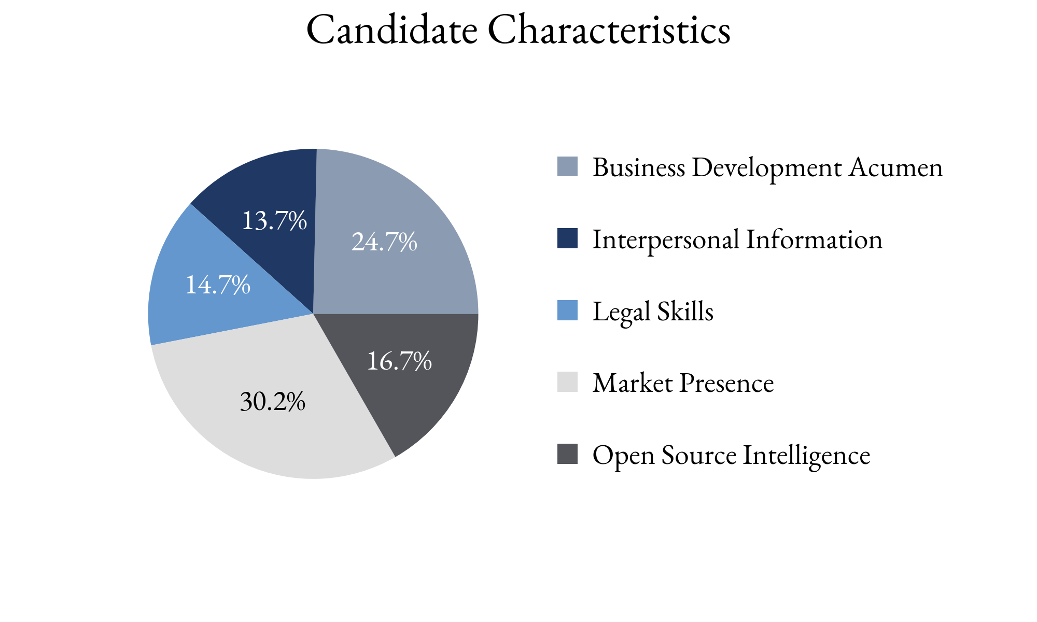

Highlighting Factors:

* No outside business
* Robust book of business given practice area
* Diverse market clients (as in not one big rainmaker)

Limiting Factors:

* Evidence of sharp elbows
* Lack of book growth compared to peers (last five years)
* Client satisfaction unclear

TIA analysts assess this score with **(*High, Medium, Low*)** confidence

based on the information able to be attained.

TIA Candidate Score is derived from open-source information as well as human intelligence gathered about the candidate utilizing an artificial intelligence platform with machine learning technology. This platform takes into account the factors highlighted for each candidate, the credibility of the human intelligence sources, candidate characteristics and attributes as well as the confidence level of TIA analysts.