TALENT REPORT

***Michael Kosnitzky***

*Partner | Pillsbury Winthrop Shaw Pittman LLP | Miami, FL*

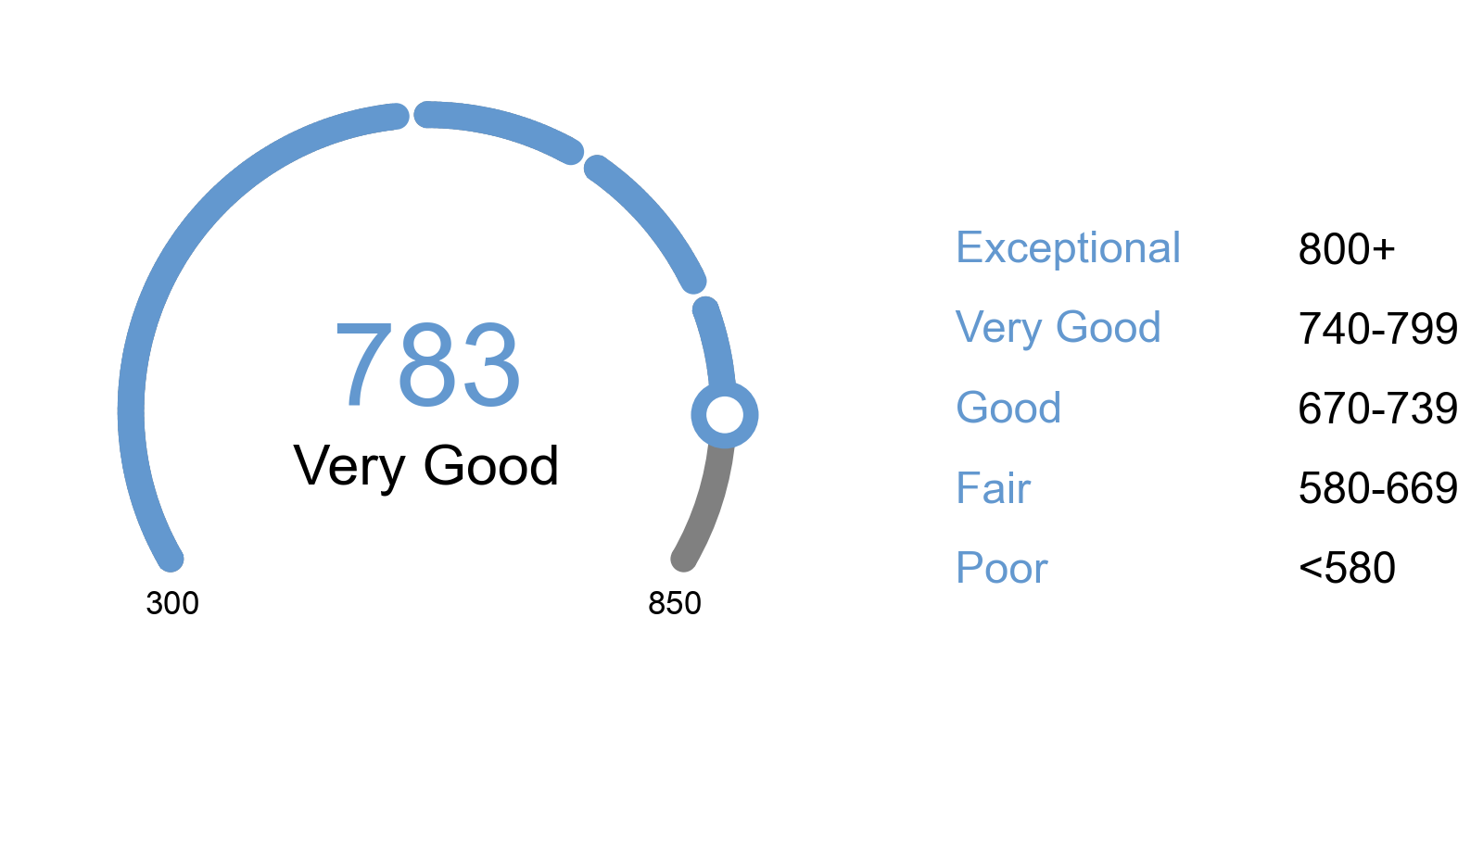

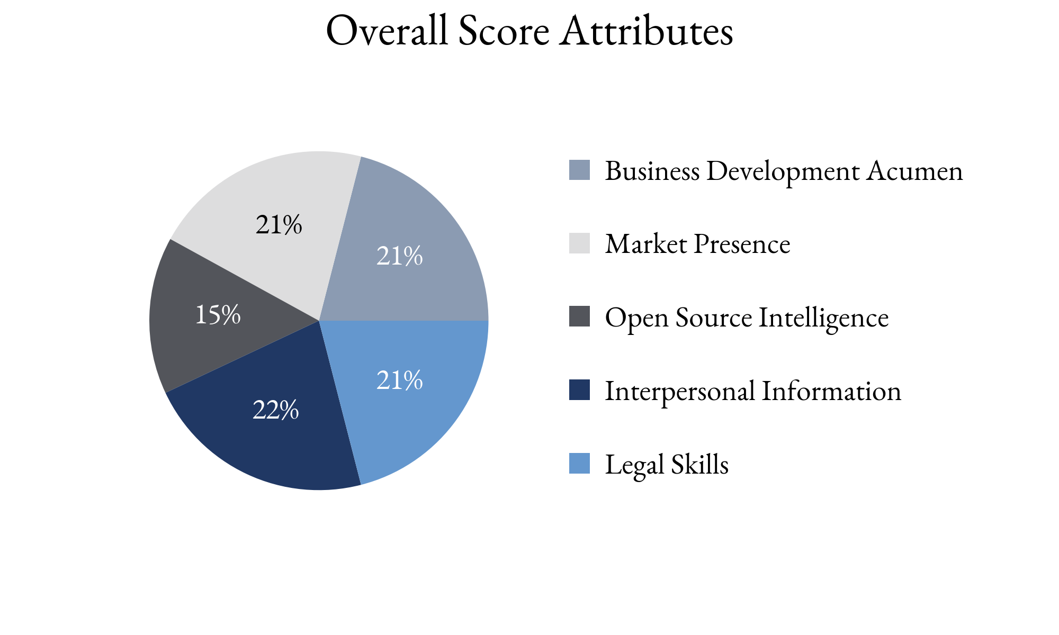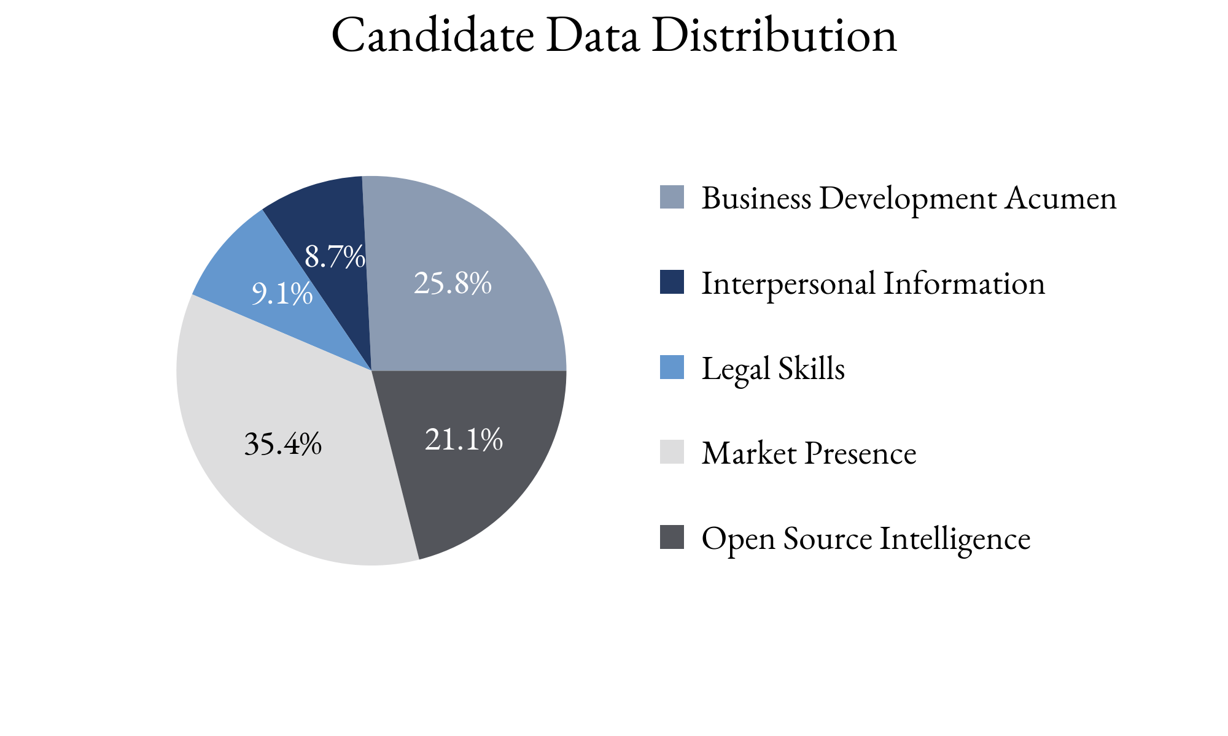

Highlighting Factors:

* Recognized for expertise
* High deal mentions in news
* Specific expertise

Limiting Factors:

* Oral advocacy acumen unknown
* No evidence of mentorship activity
* Practice promotion tactics unclear

TIA analysts assess this score with **(*High, Medium, Low*)** confidence

based on the information able to be attained.

TIA Candidate Score is derived from open-source information as well as human intelligence gathered about the candidate utilizing an artificial intelligence platform with machine learning technology. This platform takes into account the factors highlighted for each candidate, the credibility of the human intelligence sources, candidate characteristics and attributes as well as the confidence level of TIA analysts.