TALENT REPORT

***Preferred Candidate***

*Partner | Lewis Roca Rothgerber Christie LLP | Los Angeles*

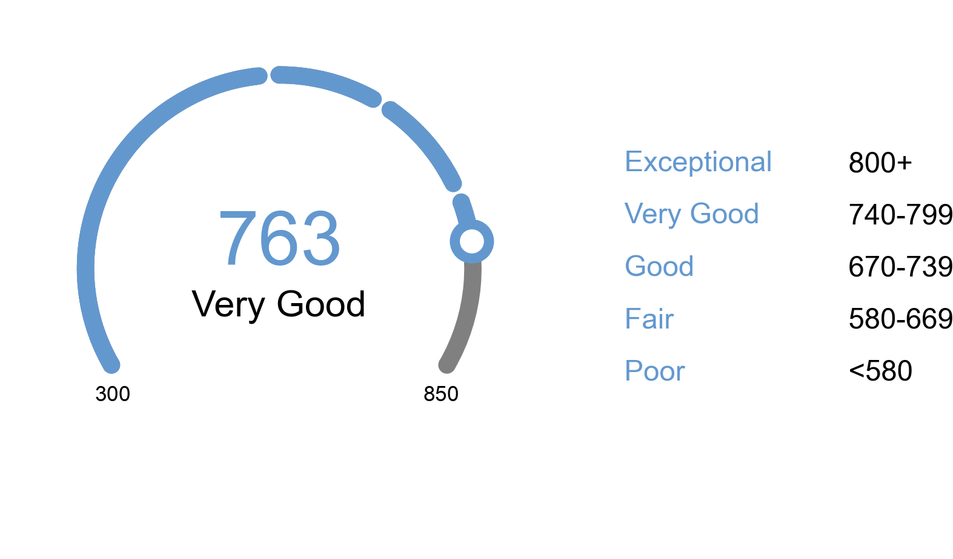

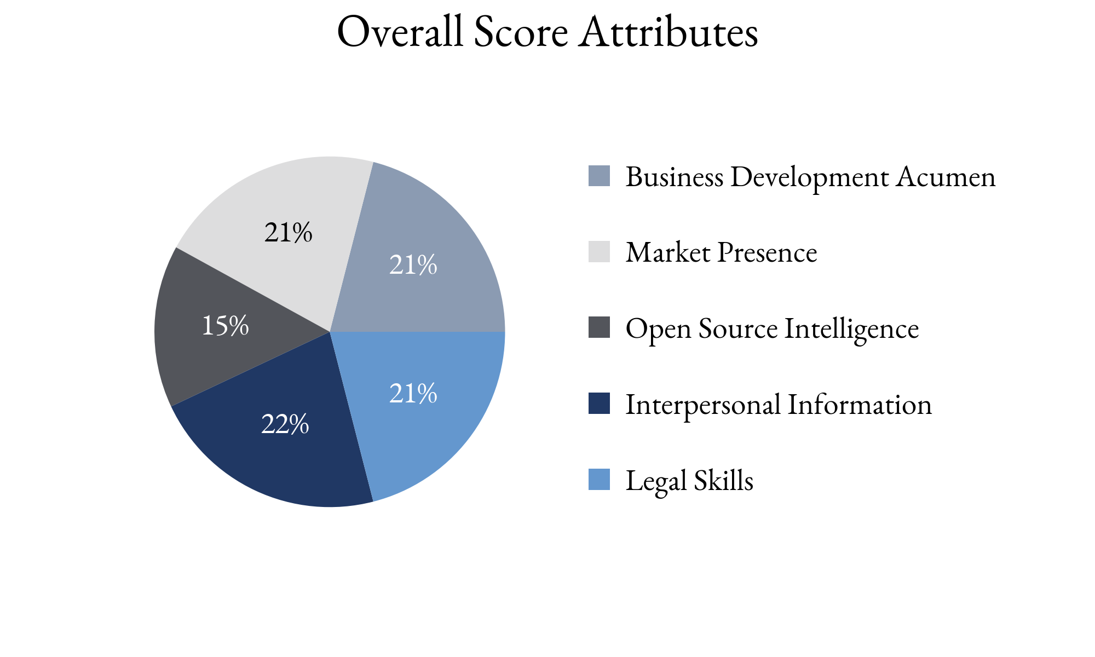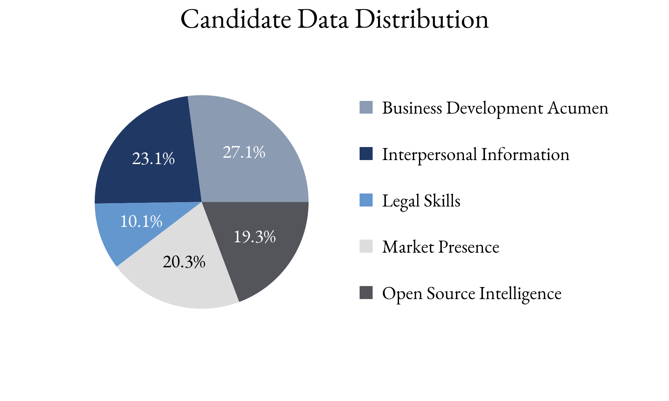

Highlighting Factors:

* Recognized for expertise
* Specific expertise
* Described as good to work with

Limiting Factors:

* Lack of book growth compared to peers (last five years)
* No evidence of referrals from peers or clients
* Writing skills unable to be verified

TIA analysts assess this score with **(*High, Medium, Low*)** confidence

based on the information able to be attained.

TIA Candidate Score is derived from open-source information as well as human intelligence gathered about the candidate utilizing an artificial intelligence platform with machine learning technology. This platform takes into account the factors highlighted for each candidate, the credibility of the human intelligence sources, candidate characteristics and attributes as well as the confidence level of TIA analysts.